ON&ON Herbal Toothpaste (150g) MRP
₹172.00

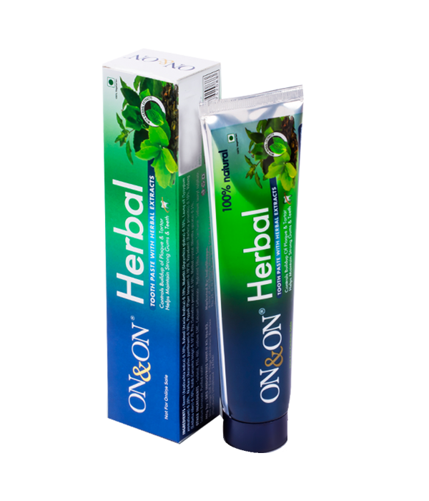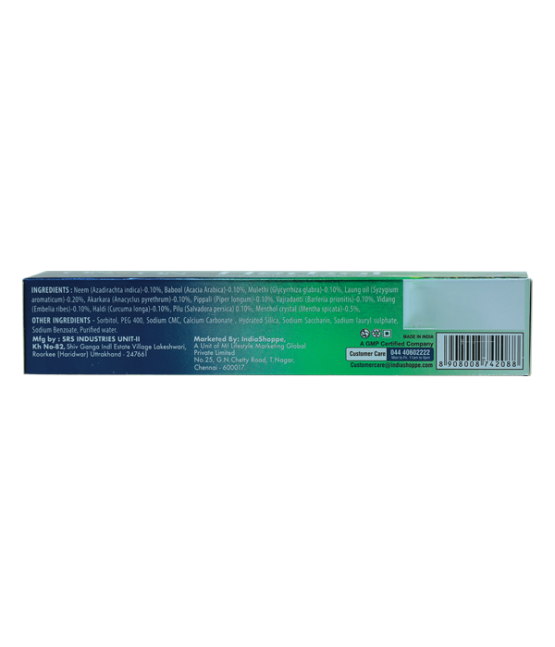

Product Description:
The toothpaste contains natural extracts of neem, clove & babul which provide strong antibacterial and antifungal properties. This helps in control of plaque and tartar build up, thereby making the gum & teeth healthy and strong, thus reducing the incidence of cavity and tooth decay. Regular use of the product will ensure complete oral hygiene.
Net Content: 150g

Directions for use: Use ON&ON Herbal Toothpaste daily by applying a pea-sized amount to your toothbrush. Brush thoroughly, ensuring coverage of teeth and gums. Rinse thoroughly with water. For best results, use twice daily as part of your regular oral care regimen to maintain strong, healthy teeth and gums naturally.

Ingredients: Neem (Azadirachta indica)-0.10%, Babool (Acacia Arabica)-0.10%, Mulethi (Glycyrrhiza glabra)-0.10%, Laung oil (Syzygium aromaticum)-0.20%, Akarkara (Anacyclus pyrethrum)-0.10%, Pippali (Piper longum)-0.10%, Vajradanti (Barleria prionitis)-0.10%, Vidang (Embelia ribes)-0.10%, Haldi (Curcuma longa)-0.10%, Pilu (Salvadora persica) 0.10%, Menthol crystal (Mentha spicata)-0.5%, Sorbitol, PEG 400, Sodium CMC, Calcium Carbonate , Hydrated Silica, Sodium Saccharin, Sodium lauryl sulphate, Sodium Benzoate, Purified water.

Storage: Store in a cool, dry place away from direct sunlight. Keep out of reach of children.

Manufactured by: Skyline Herbals Private Limited , No. 10, Mahagujarat Estate, Moraiya, Dist. Ahmedabad -382213. Mfg Lic No Gc/1474

Marketed by: Mi Lifestyle Marketing Global Private Limited. No.25, G.N.Chetty Road, T. Nagar, Chennai-600017, Tamil Nadu.

Shelf Life: Use before 24 months from the date of manufacture

Additional Information: Neem toothpaste offers multiple benefits including fighting tooth decay, teeth whitening, freshening breath, removing plaque, and tartar Its blend of herbal ingredients ensures a gentle yet effective oral care routine, maintaining optimal dental health without harsh chemicals. Ideal for those seeking natural solutions for oral hygiene with proven antibacterial properties.
Used for: Fighting tooth decay, whitening teeth, freshening breath, removing plaque and tartar.
Benefits: Fights tooth decay. Safely whitens teeth. Freshens breath. Removes plaque. Maintains optimal dental health without harsh chemicals
Elements Wellness Red Herbal Toothpaste (150g) MRP₹182.00

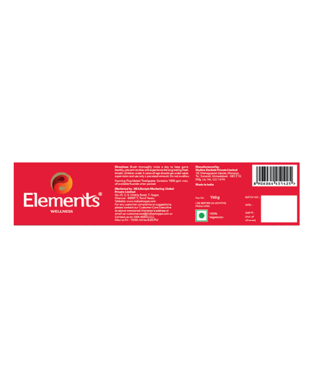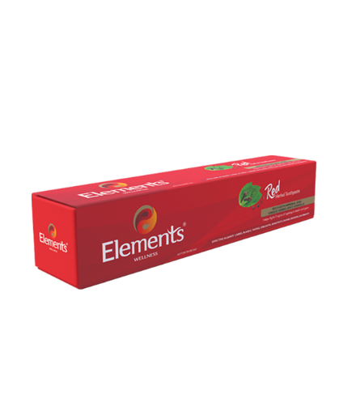

Product Description:
Enriched with Natural Tri Minerals, Blend of 9 proven Herbal Actives** and Essential Oils, the Toothpaste helps provide effective Remineralisation, Gum Strengthening, Anti-Caries, Anti-bacterial, Anti-oxidant and Anti-inflammatory benefits. ** Extracts of Licorice, Babul, Sunthi, Tomar Seed, Pippali, Kali Mirch, Clove Leaf, Camphor, Pudina. On regular use, the Tri Minerals and Bioactives in the product helps fight against caries, plaque, tartar, gingivitis, sensitivity, enamel erosion and bad breath, thereby help defy these 7 ageing signs of teeth and gum. the herbo-spice formula also helps freshening of the senses for long hours with unique organoleptic experience rich blend of humectants helps provide adequate protection for Oral Mucosa and helps improve salivation. **Please refer to the label.

Net Content: 150g
Directions for use: Brush thoroughly twice a day to keep gums healthy, prevent cavities and experience the long lasting fresh breath. Children under 6 years of age should use under adult supervision and use only a pea sized amount. Do not swallow.

Ingredients: Calcium Carbonate, Sorbitol, Aqua, Glycerin, Silica, Sodium Lauryl Sulphate, Gairic Powder, Herbal Complex (containing Extracts of Licorice, Babul, Sunthi, Tomar seed, Clove Leaf, Pippali, Kali Mirch, Camphor, Pudina), Flavour, Xanthan Gum, Sodium Monofluorophosphate, Sodium Saccharin, Methyl Paraben, Propyl Paraben.

Storage: Store in a cool, dry, hygienic place away from direct sunlight. Keep the tube tightly closed when not in use.

Manufactured by: Skyline Herbals Private Limited 10, Mahagujarat Estate, Moraiya,Ta. Sanand, Ahmedabad - 382 213. Mfg. Lic. No. GC/1474

Marketed by: Mi Lifestyle Marketing Global Private Limited No.25, G.N. Chetty Road, T. Nagar, Chennai - 600017, Tamil Nadu.

Shelf Life: Use before 24 months from the date of manufacture.

Additional Information:
Elements Wellness Red Herbal Toothpaste is a powerful oral care solution enriched with red earth minerals and a unique herbo-spice formula. This toothpaste is specially designed to combat the seven most important signs of aging in teeth and gums, ensuring comprehensive oral health.
Used for: Effective against caries, plaque, tartar, gingivitis, sensitivity, enamel erosion, and bad breath. Enriched with natural tri-minerals, the toothpaste aids in effective remineralization. Gum Strengthening: Provides gum strengthening benefits through its herbal actives. Contains antioxidant and anti-inflammatory properties.
Benefits:
Natural Tri Minerals & Herbal Actives: Enriched with a blend of 9 proven herbal actives and essential oils, including extracts of licorice, babul, sunthi, tomar seed, pippali, kali mirch, clove leaf, camphor, and pudina.
Comprehensive Oral Care: Helps fight against caries, plaque, tartar, gingivitis, sensitivity, enamel erosion, and bad breath with regular use.
Freshening of Senses: The herbo-spice formula provides long hours of freshness.
Disclaimers: Foaming Fluoridated Toothpaste. Contains 1000 ppm max. of available fluoride when packed.

Neustar Tulsi & Mint Toothpaste (100g)
MRP
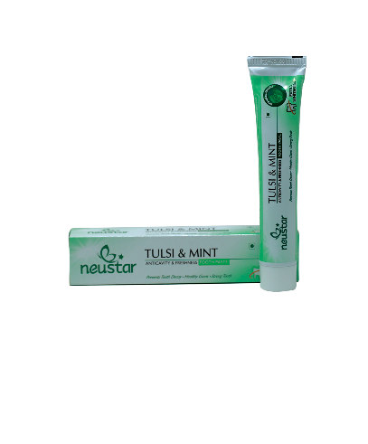
₹67.00
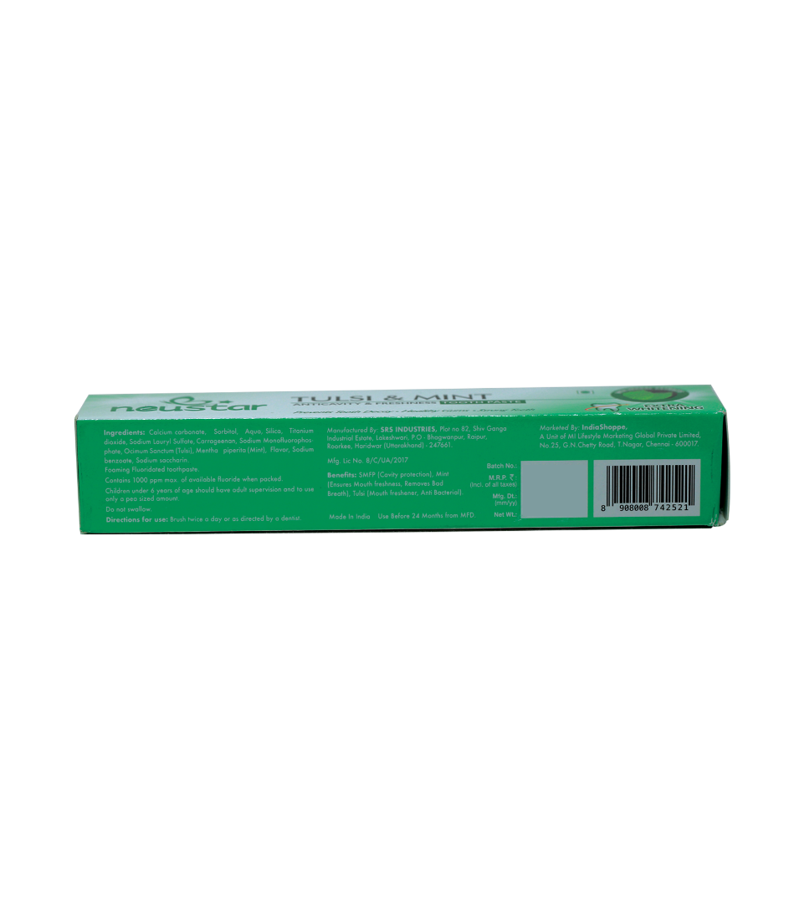

Product Description:
Provides protection from cavities; long lasting fresh breath; promotes healthy teeth and gums. This novel toothpaste provides protection from cavities while giving long lasting fresh breath. Regular use will help keep your teeth and gums healthy.
Net Content: 100g

Directions for use: Brush twice a day or as directed by a dentist. Do not swallow.

Ingredients: Calcium carbonate, Sorbitol, Aqua, Silica, Titanium dioxide, Sodium Lauryl Sulfate, Carrageenan, Sodium Monofluoro-phosphate, Ocimum Sanctum (Tulsi), Mentha piperita (Mint), Flavor, Sodium benzoate, Sodium saccharin.

Storage: Store in a cool and dry place, away from direct sunlight.

Manufactured by: SRS INDUSTRIES, Plot no. 82, Shiv Ganga Industrial Estate, Lakeshwari, P.O - Bhagwanpur, Raipur, Roorkee, Haridwar (Uttarakhand) - 247661. Mfg. Lic No. 8/C/UA/2017

Marketed by: IndiaShoppe, A Unit of MI Lifestyle Marketing Global Private Limited, No.25, G.N.Chetty Road, T.Nagar, Chennai - 600017, Tamil Nadu

Shelf Life: Use before 24 months from the date of manufacture.

Additional Information:
Neustar Tulsi & Mint Toothpaste is a novel formulation designed to provide comprehensive oral care. It offers protection from cavities while ensuring long-lasting fresh breath. Regular use helps keep teeth and gums healthy, providing a complete solution for oral hygiene.
Used for: Daily dental hygiene, cavity protection, and maintaining fresh breath.
Benefits: This toothpaste provides effective cavity protection, keeps teeth and gums healthy, and ensures long-lasting freshness by removing bad breath.
Disclaimers: Foaming Fluoridated toothpaste. Contains 1000 ppm max. of available fluoride when packed. Children under 6 years of age should have adult supervision and to use only a pea sized amount. Do not swallow.

Neustar Toothbrush (Pack Of 4)
MRP₹112.00
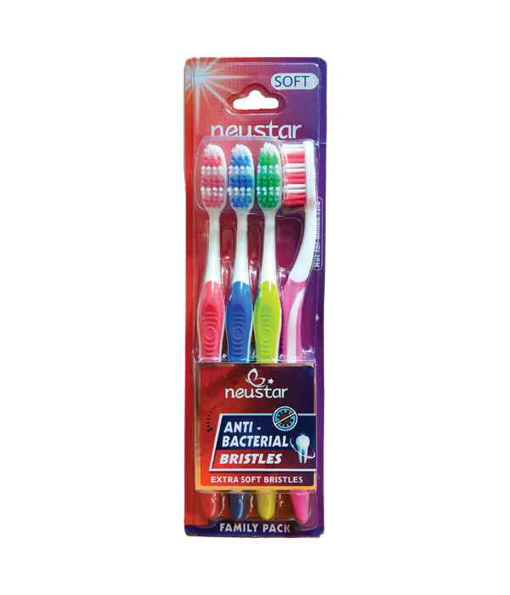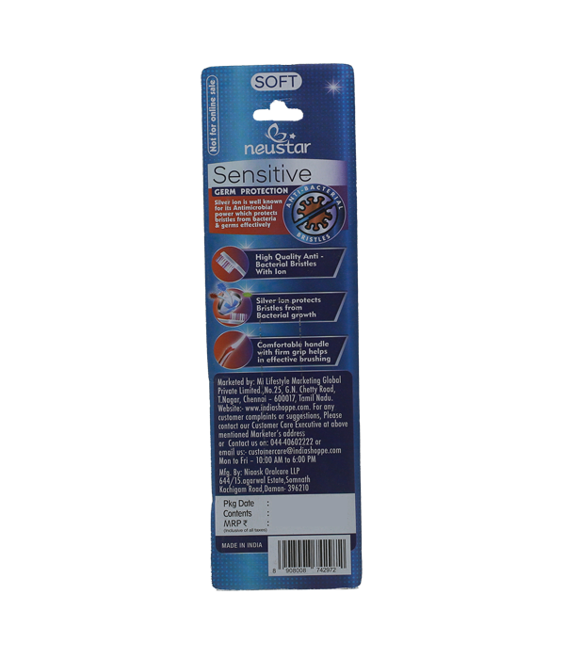

Product Description:
Neustar brings you and your family a revolutionary brushing solution with best-in-class technology to ensure a healthier and cleaner mouth. The Anti-Bacterial Toothbrush is designed to reduce plaque in hard-to-reach areas, providing a clean and healthy smile. The compact head size reaches the corners of the mouth, offering deep clean action. Experience comfortable and effective cleaning, so you can wear a confident smile every day.
Net Content: 4 units

Directions for use: To be used for daily brushing of teeth.

Storage: Store in a dry place. Rinse the toothbrush thoroughly after each use and keep it upright in a toothbrush holder. Replace the toothbrush every three months or sooner if the bristles become frayed.

Manufactured by: Niaask Oralcare LLP, 644/15, Agarwal Industrial Estate, Somnath Kachigam Road, Daman-396210. U.T. India.

Marketed by: Mi Lifestyle Marketing Global Private Limited, No.25, G.N.Chetty Road, T.Nagar, Chennai - 600017, Tamil Nadu.

Additional Information:
Combines advanced technology and design to provide superior oral care and comfort, ensuring effective cleaning with every use.
Used for: Daily teeth brushing to maintain oral hygiene, reduce plaque, and achieve a clean and healthy smile.
Benefits: Reduces plaque in hard-to-reach areas. Provides a deep clean for a healthy smile. Reaches the corners of the mouth. Soft bristles ensure gentle cleaning. Polishes away surface stains, keeping teeth clean and white.

